Partial Differential Equations

7.2 Parabolic Differential Equations

7.2-2 Implicit Method

The unsteady state heat conduction in one dimension can be written as

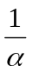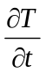 = 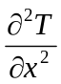

The finite difference form of the heat equation is now given with the spatial second derivative evaluated from a combination of the derivatives at time steps (n) and (n+1)

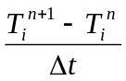 = f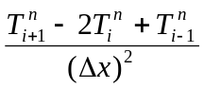 + (1 − f)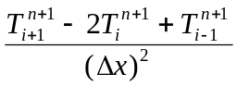

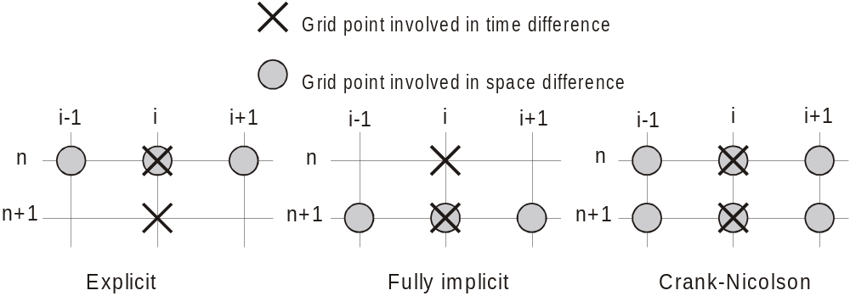
Figure 7.2-2 A computational diagram for explicit and implicit methods.

From the above formula, we will have an explicit method when f = 1 and a fully method when f = 0. In fact f can be any value between 0 and 1, however a common choice for f is 0.5. This is called the Crank-Nicolson method.

= 0.5 + 0.5

The equation can be arranged so that the temperatures at the present time step (n+1) are on the left hand side. Applying these equations to all the nodes, we will obtain a system with tridiagonal coefficient matrix.

− 0.5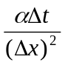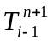 + 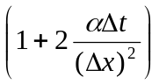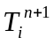 − 0.5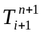 = 0.5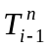 + 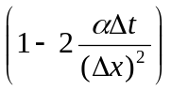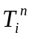
+ 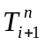

The expression is known as the diffusion number and will be denoted by d, the above equation becomes

− d + 2(1 + d) − d = d + 2(1 − d) + d

Example 7.2-2_____________________________________________________

Use the Crank-Nicolson method to solve the partial differential equation = 0.02 with the following initial and boundary conditions:

Initial conditions: T(x, 0) = 100x for 0 ≤ x ≤ 1; T(x, 0) = 100(2 − x) for 1 ≤ x ≤ 2

Boundary conditions: T(0, t) = 0; T(2, t) = 0

Solution

Let Δx = 0.2, Δt = 0.5, we have

d = = 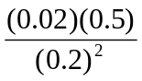 = 0.25 ≤ 

Substituting d into the equation

− d + 2(1 + d) − d = d + 2(1 − d) + d

we obtain

− 0.25 + 2.5 − 0.25 = 0.25 + 1.5 + 0.25

The initial conditions for the problem are given in the following table:

i | 1 | 2 | 3 | 4 | 5 | 6
t\x | 0 | 0.2 | 0.4 | 0.6 | 0.8 | 1.0
0 | 0 | 20 | 40 | 60 | 80 | 100
0.5 | 0

Due to the symmetry with respect to node i = 6, we have

− 0.5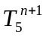 + 2.5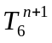 = 0.5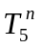 + 1.5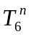
The temperatures at the time t = 0.5 are the solutions of the following equations:

i = 2 |  | 2.5T₂ | − 0.25 T₃ | = | 40
i = 3 | − 0.25 T₂ | + 2.5T₃ | − 0.25 T₄ | = | 80
i = 4 | − 0.25 T₃ | + 2.5T₄ | − 0.25 T₅ | = | 120
i = 5 | − 0.25 T₄ | + 2.5T₅ | − 0.25 T₆ | = | 160
i = 6 | − 0.25 T₅ | + 2.5T₆ |  | = | 190

The results for the above set of equations are listed in the following table:

i | 1 | 2 | 3 | 4 | 5 | 6
t\x | 0 | 0.2 | 0.4 | 0.6 | 0.8 | 1.0
0 | 0 | 20 | 40 | 60 | 80 | 100
0.5 | 0 | 20 | 39.99 | 59.92 | 79.18 | 91.84

Table 7.2-2 lists the MATLAB program and the results of the computation.

Table 7.2-2 An example of the Crank-Nicolson method ---------------
%
% Example 7.2-2, Crank-Nicolson method
%
Tn=[0 20 40 60 80 100];n=length(Tn);
n1=n-1;Tn1=Tn;
b=2.5*ones(1,n);
c=-0.25*ones(1,n);a=c;a(n)=2*a(n);
r=ones(1,n);
t=0;
fprintf('t = %8.1f, T = %8.2f %8.2f %8.2f %8.2f %8.2f %8.2f\n',t,Tn)
for k=1 : 10
t=t+0.5;
for i=2:n1;
r(i)=0.25*Tn(i-1)+1.5*Tn(i)+0.25*Tn(i+1);
end
r(6)=0.5*Tn(n1)+1.5*Tn(n);
beta=c;gam=c;y=c;
beta(2)=b(2);gam(2)=r(2)/beta(2);
for i=3:n
beta(i)=b(i)-a(i)*c(i-1)/beta(i-1);
gam(i)=(r(i)-a(i)*gam(i-1))/beta(i);
end
Tn1(n)=gam(n);
for j=1:n1-1
Tn1(n-j)=gam(n-j)-c(n-j)*Tn1(n-j+1)/beta(n-j);
end
Tn=Tn1;
fprintf('t = %8.1f, T = %8.2f %8.2f %8.2f %8.2f %8.2f %8.2f\n',t,Tn)
end

>> ex7d2d2
t = 0.0, T = 0.00 20.00 40.00 60.00 80.00 100.00
t = 0.5, T = 0.00 20.00 39.99 59.92 79.18 91.84
t = 1.0, T = 0.00 19.99 39.94 59.59 77.28 86.39
t = 1.5, T = 0.00 19.97 39.82 58.97 75.09 82.31
t = 2.0, T = 0.00 19.92 39.59 58.12 72.89 78.98
t = 2.5, T = 0.00 19.84 39.25 57.12 70.77 76.12
t = 3.0, T = 0.00 19.71 38.82 56.03 68.75 73.58
t = 3.5, T = 0.00 19.54 38.31 54.89 66.83 71.26
t = 4.0, T = 0.00 19.33 37.73 53.72 64.99 69.12
t = 4.5, T = 0.00 19.08 37.11 52.54 63.25 67.12
t = 5.0, T = 0.00 18.80 36.44 51.36 61.57 65.24
__________________________________________________________________________

In the next example, we will show the formulation of the finite difference using Crank-Nicolson method for a parabolic equation with derivative boundary conditions.
Example 7.2-3 --------------------------------------------

Use the Crank-Nicolson method to solve the partial differential equation = 0.125 with the following initial and boundary conditions:

Initial conditions: T(x, 0) = 1000 , 0 ≤ x ≤ 4

Boundary conditions: 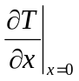= 0.36(T − 70); 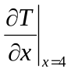= 0

Solution

Using the Crank-Nicolson method the heat equation becomes

= 0.5 + 0.5

Let d = , the above equation can be rearranged to

− d + 2(1 + d) − d = d + 2(1 − d) + d

Let Δx = 1, Δt = 1, we have

d = = 0.125 ≤

Substituting d into the above equation we obtain

− 0.125 + 2.25 − 0.125 = 0.125 + 1.75 + 0.125

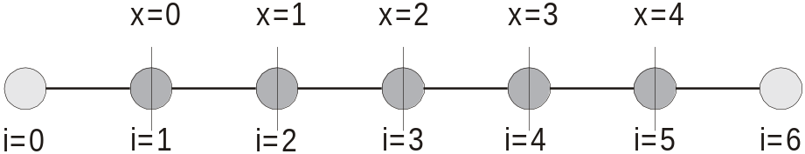
Figure 7.2-3 The nodes at any given time step.

There are five unknown temperatures at any given time as shown in Figure 7.2-3. The nodes corresponding to i = 0 and i = 5 are required to accommodate the derivative boundary conditions at the end points.

For node (i = 1)

− 0.125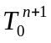 + 2.25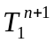 − 0.125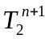 = 0.125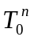 + 1.75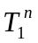 + 0.125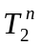

can be solved in terms of and using the boundary condition

= 0.36(T − 70) ⇒ 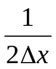(− ) = 0.36( − 70)

= − 0.72 + 50.4

Similarly, can be solved in terms of and using the same boundary condition

= − 0.72 + 50.4

The equation at node (1) is then simplified to

2.34 − 0.25 = 1.66 + 0.25 + 12.6

For 2 ≤ i ≤ 4

− 0.125 + 2.25 − 0.125 = 0.125 + 1.75 + 0.125

At node (5) = 0, therefore 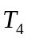 = 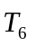

− 0.25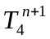 + 2.25 = 0.25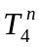 + 1.75

Table 7.2-3 lists the MATLAB program and the results of the computation.

Table 7.2-3 An example of the Crank-Nicolson method ---------------
%
% Example 7.2-3, Crank-Nicolson method with derivative boundary conditions
%
Tn=1000*ones(1,5);n=length(Tn);
n1=n-1;Tn1=Tn;
b=2.25*ones(1,n);b(1)=2.34;
c=-0.125*ones(1,n);a=c;c(1)=2*c(1);a(n)=2*a(n);
r=ones(1,n);
t=0;
fprintf('t = %8.1f, T = %8.2f %8.2f %8.2f %8.2f %8.2f\n',t,Tn)
for k=1 : 10
t=t+1;
r(1)=1.66*Tn(1)+.25*Tn(2)+12.6;
for i=2:n1;
r(i)=0.125*Tn(i-1)+1.75*Tn(i)+0.125*Tn(i+1);
end
r(5)=0.25*Tn(n1)+1.75*Tn(n);
beta=c;gam=c;y=c;
beta(1)=b(1);gam(1)=r(1)/beta(1);
for i=2:n
beta(i)=b(i)-a(i)*c(i-1)/beta(i-1);
gam(i)=(r(i)-a(i)*gam(i-1))/beta(i);
end
Tn1(n)=gam(n);
for j=1:n1
Tn1(n-j)=gam(n-j)-c(n-j)*Tn1(n-j+1)/beta(n-j);
end
Tn=Tn1;
fprintf('t = %8.1f, T = %8.2f %8.2f %8.2f %8.2f %8.2f\n',t,Tn)
end

>> ex7d2d3
t = 0.0, T = 1000.00 1000.00 1000.00 1000.00 1000.00
t = 1.0, T = 928.03 995.99 999.78 999.99 1000.00
t = 2.0, T = 875.47 985.89 998.81 999.91 999.99
t = 3.0, T = 835.70 972.73 996.76 999.68 999.95
t = 4.0, T = 804.53 958.27 993.58 999.20 999.83
t = 5.0, T = 779.30 943.48 989.42 998.40 999.60
t = 6.0, T = 758.26 928.89 984.44 997.24 999.21
t = 7.0, T = 740.27 914.79 978.82 995.69 998.60
t = 8.0, T = 724.56 901.30 972.72 993.75 997.74
t = 9.0, T = 710.61 888.47 966.28 991.44 996.59
t = 10.0, T = 698.03 876.28 959.60 988.76 995.15

---------------------------------------------------------------------------------------------------------------

